25 May 2022

Dear Councillor

Planning Consultative Committee Meeting
You are requested to attend a Planning Consultative Committee Meeting to be held at the Town Hall at 6:30pm on Tuesday 31 May 2022.

Yours sincerely

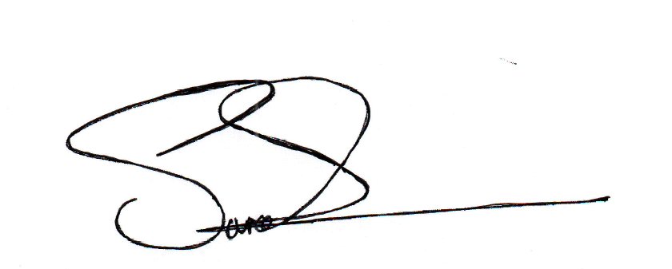

Sarah Summers
Town Clerk
To: All members of the Planning Consultative Committee
(Cllrs Coles, Curtis, Dowling, Fojtik, I Fradgley, J Fradgley, Jackson, Lee and Taylor)

STRATFORD-UPON-AVON TOWN COUNCIL
Planning Consultative Committee
NOTICE OF MEETING
Tuesday 31 May 2022
6:30pm
To be held at the Town Hall

Members of the Committee are requested to attend:
Planning Consultant:  Clerk: | Mr Neil Pearce, Avon Planning Services  Mrs Margo Galvin
Councillors: | E Coles, D Curtis, W Dowling, J Fojtik, I Fradgley, J Fradgley, T Jackson, T Lee, K Taylor

PROCEDURE FOR CONSIDERATION OF APPLICATIONS

Please note that this is not an open forum; it is a meeting of the Council’s Planning Consultative Committee (PCC) at which the public is welcome to watch and listen and may address the Committee for up to 15 minutes, 3 minutes per person on non-agenda items during public participation. Thereafter, questions cannot be taken from the audience and only those who have already registered to speak will be allowed to do so.

If you wish to speak at a PCC meeting, you must register with the Planning Clerk, Margo Galvin by emailing margo.galvin@stratford-tc.gov.uk by 12:00 noon one working day before the meeting. If you wish to support your speaking time with a presentation, you need to provide it by email at least 30 minutes before the meeting. No other electronic material is to be circulated during the meeting. You should also ensure that documents submitted do not incorporate any personal information, including faces or vehicle registration numbers in photographs.

THIS MEETING WILL BE AUDIO RECORDED

At the start of the meeting the Chairman will confirm the meeting is being recorded. Therefore, by entering the Zoom meeting, you are consenting to being recorded and to the possible use of this recording in listening for clarification of what has been said or used for training purposes. You should be aware that the Council is a Data Controller under the Data Protection Act. Data collected during this recording will be retained in accordance with the Council’s Privacy Statement.

It is requested that the audience respects the Committee and allows the meeting to progress in accordance with the procedure described below and without interruption.

Welcome to this meeting of the Town Council’s Planning Consultative Committee.

The Chairman will introduce the application and then ask the Council’s Planning Consultant to give a detailed explanation of the application.

The names of those people who have registered to speak on the application will be called in the following order:

- Objectors; (3 minutes)
- Supporters; (3 minutes)
- The applicant or their agent (3 minutes).
- Ward members not on the Committee (3 minutes)
After each speaker has finished, the Chairman will ask if the Committee has any questions to be put. Committee Members will then have the opportunity to ask for further information or clarification following which the debate will be opened up to the Committee. The Planning Consultant will be asked to comment if necessary.
Finally, the Committee will be asked to take a decision on the application, and this will take the form of a motion from a Councillor to GRANT or REFUSE or make NO REPRESENTATION substantiated by valid planning reasons. The motion will then be seconded by another Councillor. The Chairman will then request that Councillors vote on the motion.
Once the decision has been made, the Planning Consultant will electronically enter the decision and reasoning onto the District Council’s planning portal using the delegated authority of the Town Clerk. Once the Councillors have agreed the wording, it will be formally sent to the District Council. The Chairman will then call the meeting to order and move to the next agenda item.

AGENDA
 | To elect the Chairman and Deputy Chairman of the Planning Consultative Committee for the ensuing year 2022/2023;
 | Apologies for Absence;
 | Declarations of interest on items on the Agenda;
 | To receive written requests for dispensation for disclosable pecuniary interests (if any);
 | To grant any requests for dispensation as appropriate;
Consultation Presentation on Pre-Planning Applications if any;
5a)

7. | Public Participation of non-agenda items on matters under which the Council has control or is a consultative body (subject to a time limit of 15 minutes, 3 minutes per speaker);
8. | To approve draft Open Minutes of the Planning Consultative Committee Meeting held on 3 May 2022;
9. | Town Clerk’s Open Report  - List of Planning applications deferred from Chairman’s Actions meeting on 25 May 2022 with any items deferred from Additional Chairman’s Actions meeting on 30 May 2022.  - To note Action by Town Clerk after consultation with Chairman, Deputy Chairman (or their substitutes) & Avon Planning Services on 3 May 2022.  - Street Trading and Licensing Applications  3a. There are currently no street trading applications pertinent to the  Town Council.  3b. Licensing Applications:  - Notices of Decision (for information only);  - Any Other Business  5a) Terms of Reference Annual Review – these are attached as an appendix, which are subject to annual review. The Chairman has requested that these are reviewed on 25 May 2022 and attention is drawn to 4.9 and 13.  5b) Orbit Homes Housing Needs Survey. Committee is required to determine how it will respond.  5c) Worths Way green space area – see Appendix B. Consideration of green space area to be adopted by the Town Council.
  22/01287/FUL | 175a Evesham Rd.  CV37 9BS | Demolition of all buildings and construction of 7 dwellings and associated works
  1. | 22/00637/LAPREM | Wonderland, Unit 15 Bell Court, Stratford upon Avon CV37 6EX | Sale of alcohol, provision of regulated entertainment | Application date: 18/05/22  Last representation date: 15/06/22
  2. | 22/00565/LAPREM | Picnic in the Park (at Bancroft Gardens) Bancroft Gardens, Waterside, Stratford upon Avon CV37 6BA | Provision of regulated entertainment | Application Date: 06/05/22  Last representation date: 03/06/22
  3. | 22/00541/LAPREM | Zoo Sushi & Bubble Tea 3-5 Cooks Alley, Stratford upon Avon CV37 6QN | Sale of alcohol | Application date: 28/04/22  Last representation date: 26/05/22
10. | Chairman’s Verbal Report – for information only;
11. | Requests for Alterations of Recommendation – for information (if any);
12. | To register, when necessary, a representative from the Planning  Consultative Committee to attend the Stratford District Council Planning Meeting on Wednesday, 25 May, 2022 at 6:00pm;
13. | To appoint substitutes for the next Chairman’s Actions on 15 June 2022, if required;
Date of next meeting: Tuesday 21 June 2022 at 6:30pm

